EXPERIMENT-7
AIM:
To create a virtual machine with 1 cpu, 2gb ram and 15gb storage disk using a type 2 virtualization software.
PROCEDURE:
STEP 1: Download VMware workstation and installed as type 2 hypervisor.
STEP2: Download ubuntu or tiny OS as iso image file.
STEP 3: In VMware workstation->create new VM.
STEP 4: Do the basic configuration settings.
STEP 5: Created tiny OS virtual machine.
STEP 6: Launch the VM.
IMPLEMENTATION:
STEP 1: DOWNLOAD VMWARE WORKSTATION AND INSTALLED AS TYPE 2 HYPERVISOR

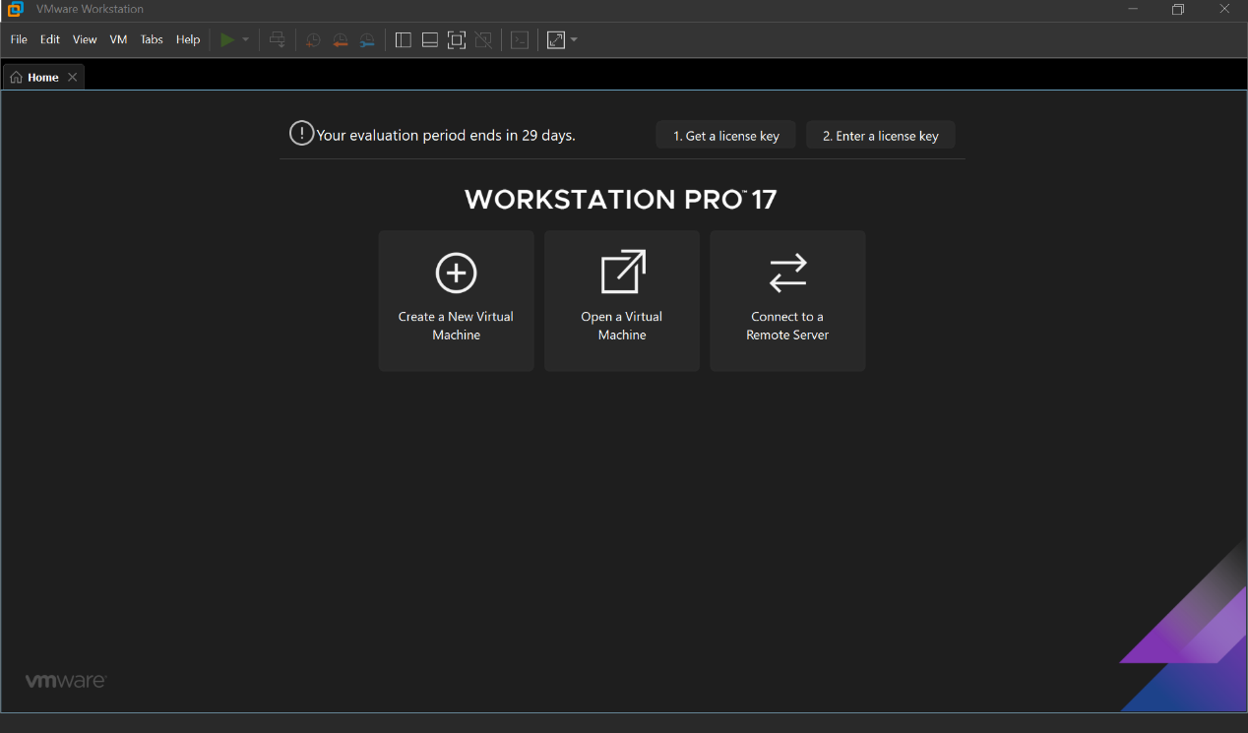
STEP2: DOWLOAD UBUNTU OR TINY OS AS ISO IMAGE FILE

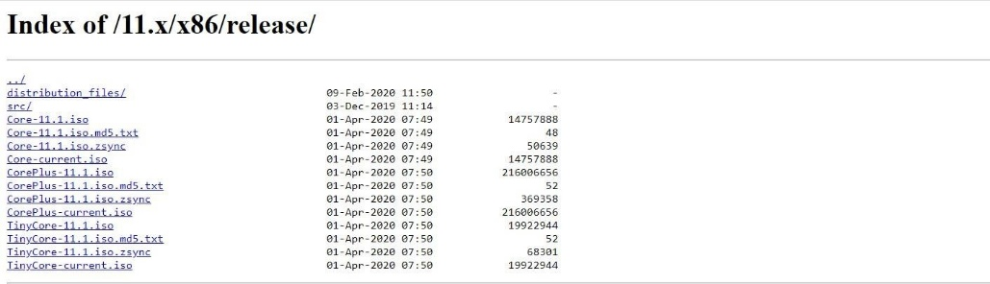

STEP 3: IN VMWARE WORKSTATION->CREATE NEW VM
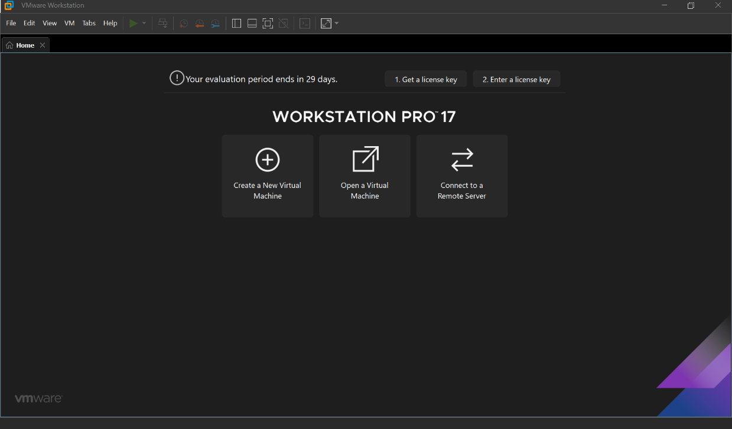
STEP 4: DO THE BASIC CONFIGURATION SETTINGS.
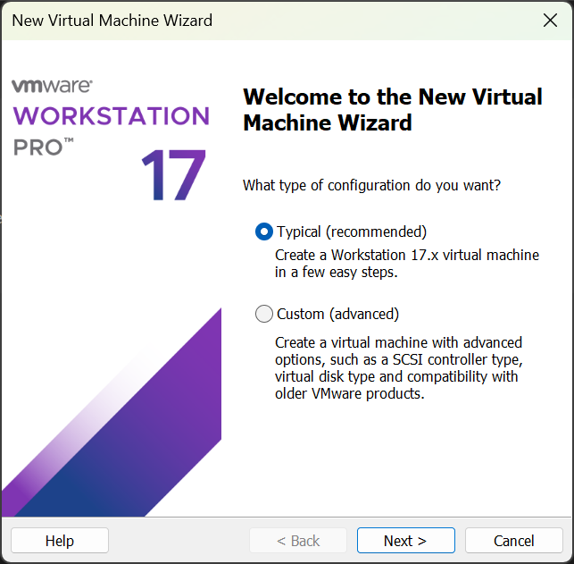

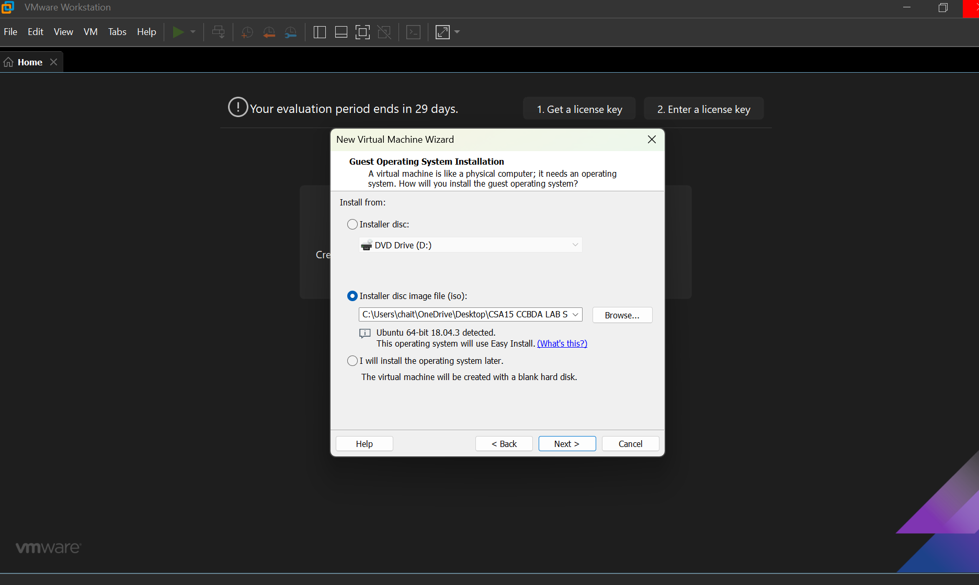

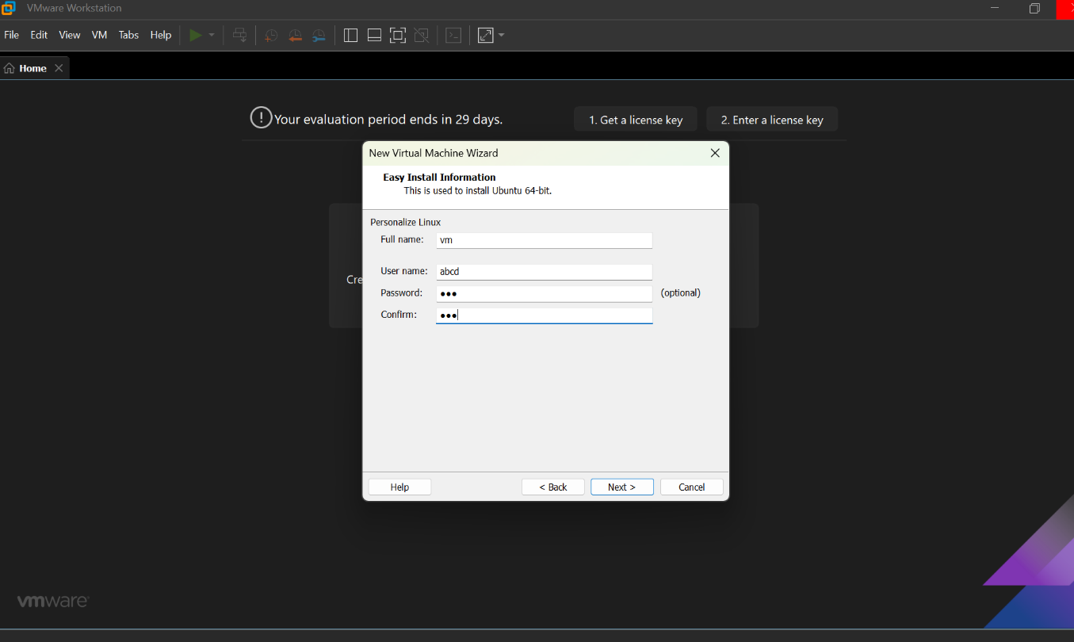

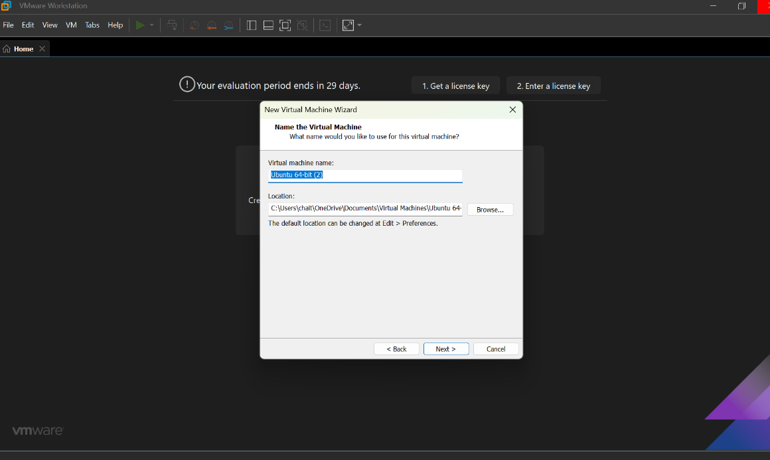
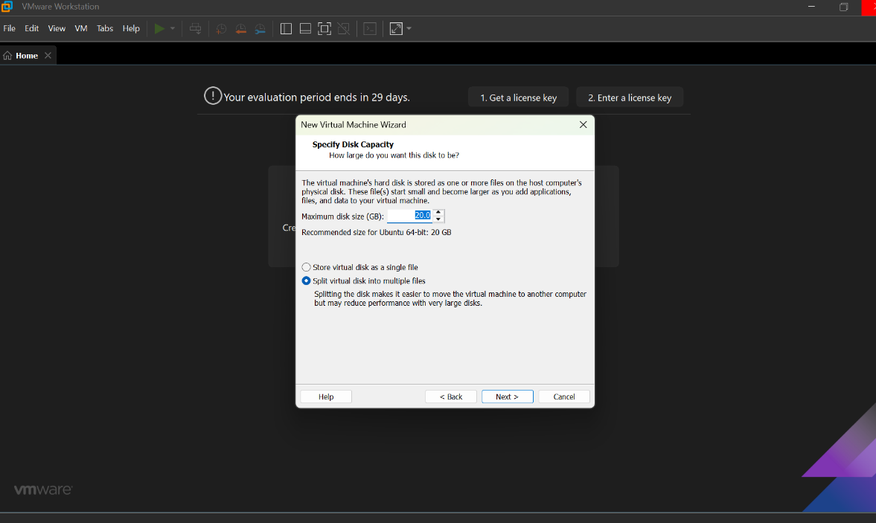
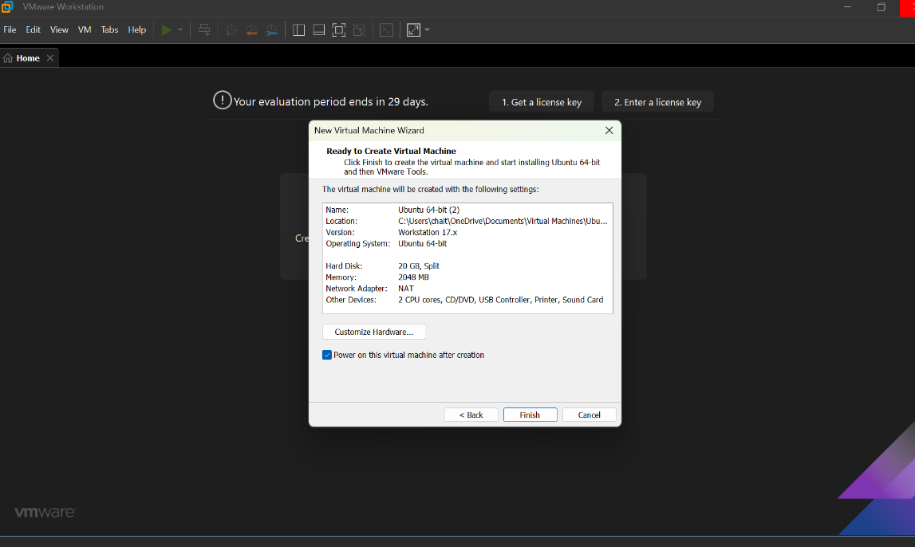

STEP 5: CREATED TINYOS VIRTUAL MACHINE

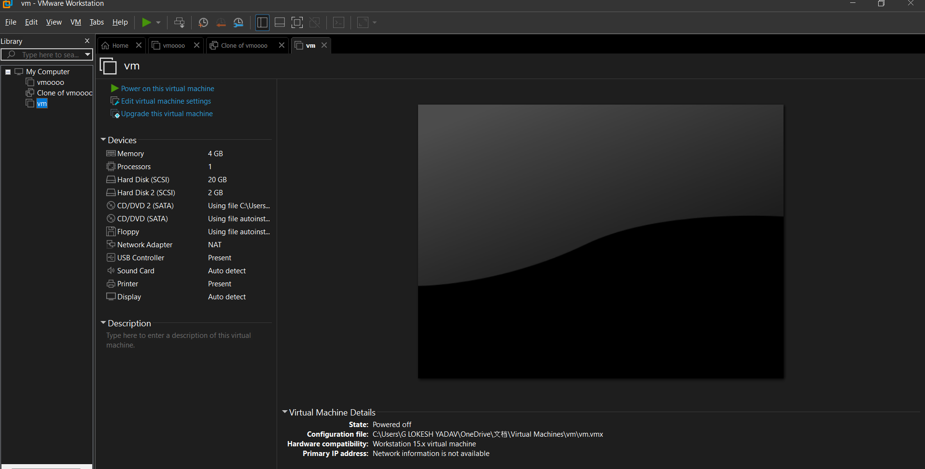

RESULTS; successfully created a virtual machine with 1 cpu, 2gb ram and 15gb storage disk using a type 2 virtualization software.

